**6. AVERAGES, ALLIGATION & MIXTUREs**

**Solution Exercise – Easy**

1. (c) : Average income = Rs. 

=  = Rs. 3500

2. (a) : Total age decreases = 20 × 2 = 40 months

= 3 years 4 months

The age of new boy = 18 years – 3 years 4 months

= 14 years 8 months.

3. (b) : Use unitary method:

In  hours, 164 typists can type 984 papers.

In 1 minute, 164 typists can type 

In 1 minute, 1 typist can type = 

(Hint:  hours = 3 minutes)

4. (c) : Average = 

= 

=  = 92.9 marks.

5. (d) : Sum = 30 × 72 = 2160

Original sum = 2160 + 28 – 88 = 2100

Correct Average = 

6. (b) : Let the original average expenditure be Rs. *x*.

Then,

40 (*x* – 2) – 30*x* = 40

⇒ 10*x* = 120 ⇒ *x* = 12

∴ Original expenditure = 30 × 12 = Rs. 360

7. (a) : Required correct mean = 

= 

8. (a) : Since, there are 400 employees, so option (a) is correct.

9. (c) : Increase in weight = 1.8 × 10 = 18 kg

New man’s weight = 65 + 18 = 83 kg

10. (c) : Given, 

∴ 42° + Tue + Wed + Thu = 192°

⇒ Tue + Wed + Thu = 150°

and 

⇒ 150° + Fri = 208°

⇒ Fri = 58°

11. (a) : Weight of student = 53 × 21 – 20 × 55

= 1113 − 1100 = 13 kg

12. (c) : Sum of the five numbers = 5 × 42 = 210

Sum of first four numbers = 4 × 40 = 160

So, fifth number = 210 – 160 = 50

13. (a) : Let the original number of boys be *n*.

∴ Sum of their weights = 43*n*

∴  = 42.5

or, 43*n* + 160 = 42.5*n* + 170

or, 0.5*n* = 10 or, *n* = 20.

14. (a) : Average age = 



15. (c) : Let the average contribution of the class be Rs. *x*

∴  = *x*

⇒ 7*x* = 49 ⇒ *x* = 7.

16. (c) : Let first number be *x*, then



*x* = 41

∴ Product of A and E = (*x* − 4) × (*x* + 4)

= 37 × 45 = 1665

17. (a) : Let, woman and her daughter ages be 2*x* and *x*.

Also,



∴ 3*x* = 84 ⇒ *x* = 28

Hence, daughter’s age is 14 years.

18. (a) : Total marks obtained by the candidates = 120 × 35

= 4200

Let passed students be *x*, then

4200 = *x* × 39 + (120 – *x*) 15

⇒ 4200 = 24*x* + 1800

⇒ 2400 = 24*x* ⇒ *x* = 100

19. (a) : Total runs in the first 10 overs = 10 × 3.2 = 32

∴ Run rate in the remaining 40 overs

= 

20. (d) : Total age of 10 students = 125 years

Total age of 20 students = 262 years

∴ Average age of 30 students

= 

21. (b) : Let the ratio of the students with 18 students to 39 students be *x* : *y*, then

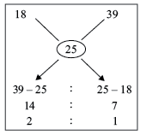

Thus the required ratio is 2 : 1

22. (b) : Cost of resultant mixture

= 



23. (c) : Cost of resultant mixture



24. (a) : The average price of the new mixture

= 

25. (b) :

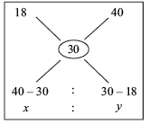



26. (a) : Average cost = 

27. (a) : Using the alligation rule,

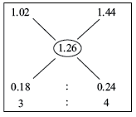

28. (d) :

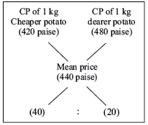

Using the alligation rule

Cheaper Potato : Dearer Potato = 40 : 20 = 4 : 2

Thus, they must be mixed in the ratio 2 : 1.

29. (c) : By rule of alligation, we have

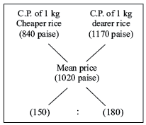

∴ Required ratio = 150 : 180 = 5 : 6

30. (c) :

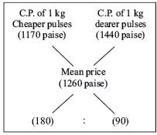

By the alligation rule



He must mix pulses in the ratio 2 : 1.

31. (c) :

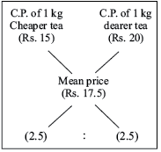

(Cheaper tea) : (Dearer tea) = 2.5 : 2.5 = 1 : 1

32. (d) : According to the rule of alligation,

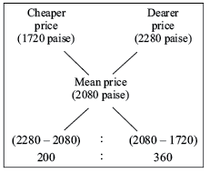

∴ Cheaper : Dearer = 20 : 36 = 5 : 9

33. (a) : According to the rule of alligation,

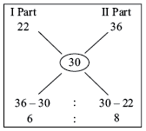

∴ Required ratio = I part : II part = 6 : 8 = 3 : 4

34. (b) : According to the rule of alligation,

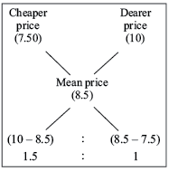

∴ Required ratio = 1.5 : 1 ⇒ 3 : 2

35. (c) : Let *C* be the required weight of cashews to be mixed with 1 kg of peanuts.

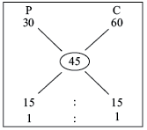

So, the ratio of peanuts & cashews is 1 : 1 they need to be mixed equally.

36. (b) : Suppose *x* be the quantity of pure wine that needs to be added to make it a 60% solution.

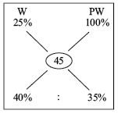

Wine = 



This gives *x* = 5.25

37. (c) : Total volume of the mixture = 12 + 34 = 46 *L*

Total amount of acid = 12 × 0.10 + 34 × 0.20 = 8

Strength of acid in mixture (in percent) = 

38. (b) : Total quantity of the new alloy = 40 + 68 = 108 kg

Total concentration of titanium = 40 × 0.13 + 68 × 0.60 = 46

Concentration of titanium in the resultant mixture (in percent) is 

39. (b) : By rule of alligation

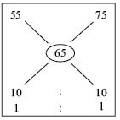

The required ratio is 1 : 1.

So, 200 kg of Rs. 75 per kg seeds need to be taken.

40. (c) : It is given that the shopkeeper makes 25% profit by selling the mixture at Rs. 40/kg.



Therefore, cost of the mixture is Rs. 32/kg.

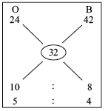

So, they need to be mixed in 5 : 4 ratio.

Therefore, shopkeeper has to put 36 kg of basmati rice.

41. (c) : The mean value is Rs. 15 and the price of water is Rs. 0.

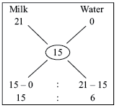

By alligation rule, milk and water are in the ratio of

15 : 6 = 5 : 2

Therefore, quantity of milk in the mixture = 

42. (d) : S.P. of 1 kg of mixed rice = Rs. 17.50, gain = 25%

C.P. of 1 kg of mixed rice = 

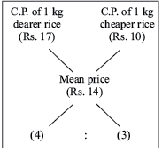

Required ratio = 4 : 3

43. (b) : SP of 1 kg = Rs. 9.6 = 

⇒ CP = Rs. 8

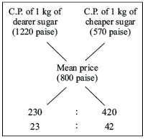

∴ 

If cheaper sugar is 42 kg, dearer one = 23 kg. If cheaper sugar is 252 kg, dearer one = 

44. (d) : According to the rule of alligation,

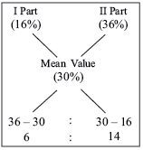

I part (16%) : II part (36%) = 6 : 14 = 3 : 7

∴ Quantity sold at 16% profit = 

45. (a) : According to the rule of alligation,

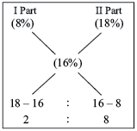

I part (8%) : II part (18%) = 2 : 8 = 1 : 4

∴ Quantity sold at 18% = 

46. (c) : Cost of resultant mixture





∴ SP = 

= 

47. (c) : C.P. of a unit quantity of 1st kind = Rs. 7.40

C.P .of a unit quantity of 2nd kind = Rs. 7.10

Mean price = Rs.7.28

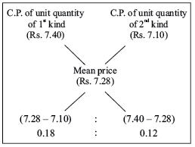

Required ratio = 0.18 : 0.12 = 3 : 2

48. (d) : C.P. of a unit quantity of 1st kind = Rs. 30

C.P. of a unit quantity of 2nd kind = Rs. 60

Mean price = 325p

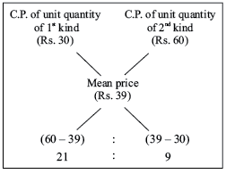

Required ratio = 9 : 21 = 3 : 7

They must be mixed in the ratio 3 : 7

49. (b) : C.P. of a unit quantity of 1st kind = Rs. 82

C.P. of a unit quantity of 2nd kind = Rs. 92

Mean price = Rs. 84.50

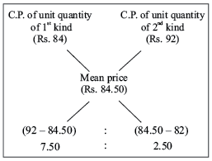

Required ratio = 7.50 : 2.50 = 3 : 1

50. (d) : Since, the average has to be between the two numbers, it is not possible get a mixture at Rs. 5.60.

**Solutions Exercise – Medium**

1. (d) : Milk in *V*1 =  of whole, Milk in *V*2 =  of whole.

Milk in mixture of *V*1 and *V*2 =  of whole.

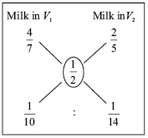

∴ Required ratio = 

2. (d) : Total weight of 29 students = 29 × 48 = 1392 kg

If teacher weight is included, then total weight

= 30 × 48.5 = 1455 kg

∴ Weight of teacher = 1455 – 1392 = 63 kg

3. (c) : Total of 40 innings = 40 × 50 = 2000

Total of 38 innings = 38 × 48 = 1824

∴ Sum of highest and lowest score

*x* + *y* = 2000 – 1824

⇒ *x* + *y* = 176 ..... (1)

and *x* – *y* = 172 ..... (2)

Solving Eqs. (1) and (2), we get

*x* = 174

4. (a) : Let the three numbers be *a*, *b* and *c*.

*a* = 2*b* = 3*c*

∴ 

Given,



⇒ 

⇒ *a* = 72

5. (c) : Total salary of 75 workers = Rs. 426000

Total salary of 25 workers = Rs. 135000

Total salary of 30 workers = Rs. 171000

∴ Total salary of remaining 20 workers

= 426000 – (135000 + 171000) = 120000

∴ Mean salary of 20 workers = 

6. (c) : Total expenditure for the year

= [2200 × 3 + 2250 × 4 + 3120 × 5]

= 6600 + 9000 + 15600

= Rs. 31200

Total saving = Rs. 1260

Total income = expenses + savings

= 31200 + 1260 = Rs. 32460

Average income = 

7. (c) : Total score of first three friends = 15 × 3 = 45

And total score of last three friends = 16 × 3 = 48

∴ Total score of four friends = 45 + 19 = 64

∴ Score of first friend = 64 – 48 = 16

∴ Required percentage = 

8. (a) : Total marks of a student in 8 subjects = 8 × 87 = 696

Total marks of a student in 6 subjects = 6 × 85 = 510

∴ Remaining marks of 2 subjects = 186

Let the second highest marks be *x*, then highest marks be *x* + 2.

∴ *x* + *x* + 2 = 186

⇒ 2*x* = 184

⇒ *x* = 92

∴ Highest marks is *x* + 2 = 94

9. (d) : Let the age’s of three children be *x*1, *x*2 and *x*3.

Then,



⇒  ..... (1)

Also,

M + *x*1 = 39 ..... (2)

From Eqs. (1) and (2), we cannot determined the value of *x*2.

10. (b) : Let the total number of boys and girls be *B* and *G* respectively.

∴ Total score of boys = 71*B*

Total score of girls = 73*G*

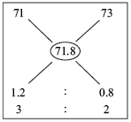

Total score of the class = 71.8 (*B* + *G*)

∴ 71*B* + 73*G* = 71.8 (*B* + *G*)

⇒ 0.8*B* = 1.2*G* ⇒ 

11. (d) : Let present age of husband, his wife and son be *x*, *y* and *z* respectively.

According to the given condition,



⇒ *x* + *y* + *z* = 90 ..... (1)

and 

⇒ *y* + *z* = 50 ..... (2)

From Eqs. (1) and (2), we get

*x* = 90 – 50 = 40 years

12. (b) : Total weight of 45 students = 45 × 52 = 2340

Total weight of 5 students who leave = 5 × 48 = 240

Total weight of 5 students who join = 5 × 54 = 270

Hence, new total weight of 45 students

= 2340 – 240 + 270 = 2370

∴ Average = 

13. (d) : Let the ninth person spent Rs. *x*.

Then, average of all the nine

= 

Given,



9*x* = 96 + *x* + 72

⇒ 8*x* = 168

⇒ *x* = 21

Hence, total money spent = 96 + 21 = Rs. 117

14. (c) :

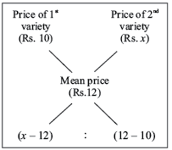



⇒ (*x* **−** 12) × 3 = 4

⇒ 3x = 4 + 36 = 40

∴ *x* = 

Hence, the price of the 2nd variety of rice is Rs. 13.33 per kg.

15. (c) :

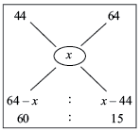

∴ 

∴ *x* = 48

Hence, the average of the new class will be 48 marks.

16. (b) :

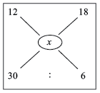



⇒ *x* = 13

Alternate **Method:**

The corresponding ratio is 30 : 6 = 5 : 1

Now reverse the ratio, which is 1 : 5

Now divide the difference of 12 and 18 in the ratio of 1 : 5

*i.e.*, divide 6 into two parts in the ratio of 1 : 5, then the average price of mixture is 12 + 1 = 13 or 18 **−** 5 = 13

17. (a) : Using alligation,

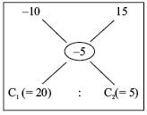

*C*1 and *C*2 are the cost of each flat,





and *C*1 = 64 lakhs

18. (c) : 16.67% profit means there is one part water and 6 part is milk. So the required ratio of water and milk in the mixture is 1 : 6

19. (b) : Cost price of the mixture = 

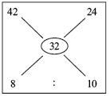

Using the alligation rule, we have



Therefore, the required quantity of mangoes at Rs. 42 per kg

= 

20. (d) : Total quantity of mixture = 80 litre

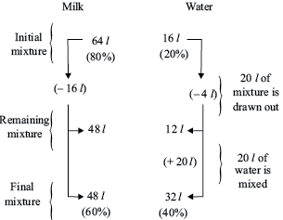

21. (b) : Alcohol in 1 *L* mixture of *A* = 

Alcohol in 1 *L* mixture of *B* = 

Alcohol in the mixture = 

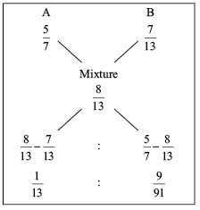

∴ Required ratio = 

22. (d) : Let the cost price of the mixture be Rs. *x* = 2.7

Now the average cost price of mixture

= Rs. (3 **−** 0.3) = Rs. 2.7

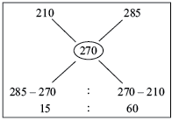

Therefore, the ratio of cheaper to costlier rice is 15 : 60, *i.e.*, 1 : 4

23. (b) : Concentration of milk in the first solution = 94%

Concentration of milk in the second solution = 0%

[pure water contains 0% milk]

Using the alligation cross,

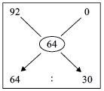

Ratio of the two solutions = 64 : 30 = 32 : 15

Since the wright of the first solution is 32 litres, hence the weight of second solution (pure water) is 15 litres.

24. (b) : When the water is freely available and all the water is sold at the price of the milk, then the water gives the profit on the cost of 40 litres of milk.

Therefore, profit percentage = 

25. (a) :

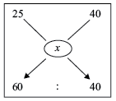



*x* = 31

26. (b) : Wine = 24% of 20 = 4.8

Water = 20 − 4.8 = 15.2

Now, let *x* litres of water is added.

So, Total = 20 + *x*

Now, 15% of total = 4.8

Total = 

So, 12 litres of water should be added.

27. (d) : Total amount of mixture is 60 litre

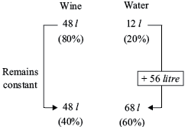

In this process the quantity of wine remains constant but its percentage decreases.

Initially we have 48 litre wine and 12 litre water. Now we are required to have 60% water and remaining 40% wine in the new mixture.

Thus we have added up 56 litre water in the original mixture.

28. (c) : Selling price = Rs. 50 ; Profit = 25%

Therefore, the cost price = Rs. 40, which is the average price.

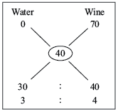

∴ Ratio is 3 : 4.

29. (c) : Proportion of petrol in the first solution = 

Proportion of petrol in the second solution = 

Proportion of petrol in the final mixture = 

Using the alligation,

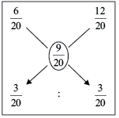

∴ Ratio of weights of two solutions = 1 : 1

30. (b) :

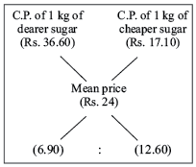

(Dearer sugar) : (Cheaper sugar) = 6.90 : 12.60 = 69 : 126

If cheaper sugar is 126 kg, dearer sugar = 69 kg.

If cheaper sugar is 65 kg, dearer sugar

= 

31. (c) : Using alligation we find the amount of nickel

(average amount of nickel in the final mixture is *x*)

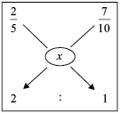

⇒ 

32. (b) :

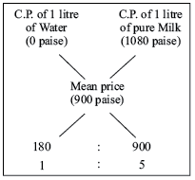

∴ 

∴ Amount of Milk in the mixture = 

33. (b) :

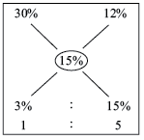

By the alligation rule we find the wine containing 30% of spirit and wine containing 12% of spirit should be mixed in the ratio 1 : 5 to produce a mixture containing 15% of spirit.

This means that  of the butt of sherry was left, that is to say the butler drew out  of the butt.

∴ of the butt was stolen.

34. (a) : Take 7 l of the solution of each mixture,

(LCM of 5 + 2, 6 + 1, 4 + 3)

∴ Net amount of water in the resulting mixture,



The net amount of alcohol is,



Ratio is, 9 : 12 = 3 : 4.

35. (d) : The total interest of one year

Therefore, the average rate of interest =  17.5%

Thus,

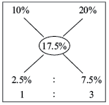

Hence the ratio of amount which is lent at 10% per annum to the amount lent at 20% per annum is, 1 : 3.

Therefore, the amount which is lent out at 10% per annum is Rs. 1500.

36. (b) :

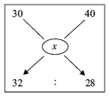



40 − *x* = 32

*x* − 30 = 28

*x* = 35.33

37. (c) :

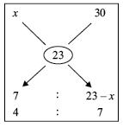

∴ 

∴ *x* = Rs. 10.75 per litre

Hence, the 3 litre milk brand costs Rs. 10.75 per litre.

38. (d) : Mean amount = 

According to the rule of alligation,

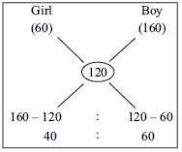

Girl : Boy = 40 : 60 = 2 : 3

∴ Number of Boys = 

39. (c) : Let the three numbers be *a*, *b* & *c*

 = 30 or *a* – *c* = 60

40. (a) : Milk in 1 litre mixture of *A* =  litre.

Milk in 1 litre mixture of *B* =  litre.

Milk in 1 litre mixture of *C* =  litre.

By rule of alligation we have required ratio *X* : *Y*.

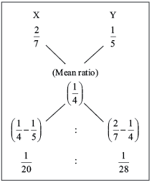

So, Required ratio =.

41. (d) : Let the rate of second quality be Rs. *x* per kg.

C.P. of 1 kg wheat of 1st 980 p

Step **I:**

S.P. of 1 kg of mixture = Rs. 9.24

Gain = 10%

C.P. of 1 kg of mixture = Rs. 8.40

Mean price = Rs. 8.40

Step **II:**

C.P. of 1 kg of sugar of 1st kind = 900 p

C.P. of 1 kg of sugar of 2nd kind = 700 p

Mean price = 840 p

By the rule of alligation, we have:

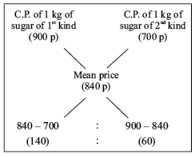

Required ratio = 140 : 60 = 7 : 3

Step **III:**

Let *x* kg of sugar of 1st kind be mixed with 27 kg of 2nd kind

7 : 3 = *x* : 27

= 



42. (a) : Let the rate of second quality be Rs. *x* per Kg.

C.P. of 1 kg wheat of 1st kind = 930 p

C.P .of 1 kg wheat of 2nd kind = *x* p

Mean price = 1000p

By rule of alligation we have required ratio 8 : 7

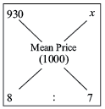



*x* = 10.80 per kg

43. (c) : Let the quantity of the wine in the cask originally be *x* litres.

Using formula:

Final Amount of solute that is not replaced

= 

Or

Final ratio of solute not replaced to total

= 

Then ratio of wine to total solution in cask after 4 operations:

=  (considering 2nd formula here)

= 

3*x* − 24 = 2*x*

*x* = 24 litres.

44. (d) : Suppose the vessel initially contain 12 litres of liquid.

Let *x* litres of this liquid is replaced with water.

Quantity of water in new mixture = 

Quantity of syrup in new mixture = 

= 

60 + 7*x* = 84 − 7*x*

14*x* = 24

*x* = 

So, part of the mixture replaced = 

45. (b) : Since, first and second varieties are mixed in equal proportions.

So, their average price = 

By the rule alligation,

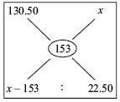

= 

*x* = 175.50

46. (a) : By applying rule of alligations and mixtures

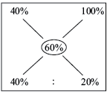

So, the two mixtures should be added in ratio 2 : 1

Required amount of spirit = 

7. (d) : In vessel *A*, milk =  of the weight of mixture.

In vessel *B* milk =  of the weight of mixture.

Now, we have to form a mixture in which milk be of the weight of the mixture.

Now according to rule of alligation :

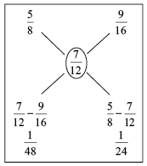

Required ratio = 

48. (a) : Let cost price of wine be Rs. 1 per liter, then S.P. of mixture is also Rs. 1 per litre

Now, C.P. of mixture be = 

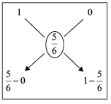



Required ratio = 1 : 5

49. (c) : Suppose the vessel initially contains 8 litres of liquid.

Let *x* litres of this liquid be replaced with water.

Quantity of water in new mixture = 

Quantity of milk in new mixture = 



⇒ 5*x* + 24 = 40 − 5*x*

⇒ 10*x* = 16

*x* =

So, part of the mixture replaced =

50. (b) : Assume the capacity of the two containers is 198 litres each.

When we mix 198 litres of the first and 198 litres of the second the amount of the syrup would be

The amount of water would be 396 − 149 = 247 litres

**Solution Exercise – Difficult**

1. (c) : Let *e* be the number of employees.

We are given that 20% of the employees are workers. Now, 20% of *e* is 

Hence, the number of workers is .2*e*

All the remaining employees are executives, so the number of executives equals

(The number of Employees) – (The number of Workers)

= 

The annual income of each worker is Rs. 390. Hence, the total annual income of all the workers together is:

= 

Also, the annual income of each executive is Rs. 420. Hence, the total income of all the executives together is:

= 

Hence, the total income of the employees is : 78*e*+340*e* = 418*e*.

The average income of all the employees together equals:

= 

= 

2. (a) : Total cost of 10 books = Rs. 120

Total cost of 8 books = Rs. 94

⇒ The cost of 2 books = Rs. 26

Let the price of each book be *x* and *y*.

⇒ *x + y* = 26 ..... (1)

Given that the price of 1 book is 60% more than the other price

= 

= 



*y* = 10

Substituting *y* = 10 in (1) we get,

*x* + 10 = 26

*x* = 16

3. (a) : Let the three numbers be *x*, *y*, and *z*. We are given that







Summing the three equations yields



*x + y + z* = 18

The average of the three numbers is.

4. (a) :

(a)

Let *a*, *b*, and *c* be the annual incomes of Ram, Shyam, and Pratap, respectively.

Now, we are given that

The arithmetic mean of the annual incomes of Ram and Shyam was Rs. 3800. Hence, 

Multiplying by 2 yields *a + b* = 2 × 3800=7600.

The arithmetic mean of the annual incomes of Suresh and Pratap was Rs. 4800.

Hence, 

Multiplying by 2 yields *b + c* = 2 × 4800 = 9600.

The arithmetic mean of the annual incomes of Pratap and Ramesh was Rs. 5800.

Hence, 

Multiplying by 2 yields *c + a* = 2 × 5800 = 11,600

Summing these three equations yields:

(*a + b*) + (*b + c*) + (*c + a*) = 7600 + 9600 + 11600

2*a* + 2*b* + 2*c* = 28,800

*a + b + c* = 14,400

The average of the incomes of the three equals the sum of the incomes divided by 3:

= 

5. (c) : Series of consecutive numbers goes like *x*, *x*  + 1, *x*  + 2, *x* + 3, *x*  + 4, .... and so on.

According to the formula,

Average of consecutive numbers

= 

= 

*x* = 19

8th consecutive number is *x* + 7

= 19 + 7

= 26

6. (d) : Let the present age of the husband = *h*

Present age of the wife = *w*

Present age of the child = *c*

3 years ago, average age of husband, wife and their child = 27

⇒ Sum of age of husband, wife and their child before 3 years = 3 × 27 = 81

⇒ (*h* − 3) + (*w* − 3) + (*c* − 3) = 81

⇒ *h + w + c* = 81 + 9 = 90 ..... (1)

5 years ago, average age of husband and child = 20 ⇒ Sum of age of husband and child before 5 years = 2 × 20 = 40

⇒ (*h* − 5) + (*c* − 5) = 40

⇒ *h + c* = 40 + 10 = 50 ..... (2)

Substituting equation (2) in equation (1),

⇒ *w* + 50 = 90

⇒ *w* = 90 − 50 = 40

⇒ Present age of the wife = 40

7. (a) : Let the quantity of the wine in the cask originally be *x* litres.

Then, quantity of wine left in cask after four operations

= 

∴ 

= 

⇒ *x* = 48

8. (a) : The resultant mixture is sold at a profit of 20% at Rs.96/kg

*i.e*. 1.2 (cost) = Rs.96 ⇒ Cost =  = Rs.80 / kg.

Let the three varieties be *A*, *B*, and *C* costing Rs.60, Rs.75 and Rs.100 respectively.

The mean price falls between *B* and *C*.

Hence the following method should be used to find the ratio in which they should be mixed.

Step **I:**

Find out the ratio of *Qa* : *Qc* using alligation rule



Step **II:**

Find out the ratio of *Qb* : *Qc* using alligation rule

= 

Step **III:**

*Qc*, the resultant ratio of variety *C* can be found by adding the value of *Qc* in step I and step II = 1 + 1 = 2.

However, in CAT if you try and solve the problem using the above method, you will end up spending more than 2, and may be 3 minutes on this problem, which is a criminal mismanagement of time.

The best way to solve a problem of this kind in CAT is to go from the answer choices as shown below

The resultant ratio *Qa* : *Qb* : *Qc* : : 1 : 4 : 2

1 kg of variety *A* at Rs.60 is mixed with 4 kgs of variety *B* at Rs.75 and 2 kgs of variety C at Rs.100.

The total cost for the 7 kg = 60 + (4 × 75) + (2 × 100) = 60 + 300 + 200 = 560.

Cost per kg of the mixture = 

Even assuming that you hit upon the right answer as the last choice, you will still be better of going back from the answer

9. (b) : The amount of petrol left after four operations

= 

= 

= 

= 

Hence, the amount of Kerosene = 400 − 163.84

= 236.16 litres

10. (c) : Let the initial amouint of wine be *x* litres.

= 

= 

= 

*x* = 150 litres

11. (c) : The sum of scores of top four students = 1356

Maximum possible score possible for top three student

= 352 × 3 = 1056

Hence, the maximum possible score for the fourth student

= 1356 − 1056 = 300

12. (b) : Let the value of milk = 3*x* litres and volume of water = 5*x* litres

When 20% of mixture is taken out

Volume of milk left = litres = 2.4*x* litres

Volume of water left =  = 4*x* litres

And 1.6*x* litres of milk is added, New ratio = 1 : 1

Similarly, proceeding we get option (b) as answer.

13. (c) : Iron in 4 kg = kg

and Copper in 4 kg = 

Iron in 5 kg = 

Copper in 5 kg = 

Therefore, Iron in mixutre

and Copper in the mixture = 

Therefore, the required ratio = 49 : 221.

14. (b) :

|  |  |  |
| --- | --- | --- |
| Milk | Water |  |
| 52% | 48% | (initially) |
| 64% | 36% | (after replacement) |

Left amount = Initial amount 





*k* = 28 litres

15. (c) :

|  |  |  |
| --- | --- | --- |
| Wine | Water |  |
| 6 L | 18 L |  |
| 1 : 3 | |  |
| 25% | 75% | (original ratio) |
| 50% | 50% | (required ratio) |

In this case, the percentage of water being reduced when the mixture is being replaced with wine.

So, the ratio of left quantity to the initial quantity is 2 : 3.

Therefore,





*k* = 8 litres

16. (b) : The S.P. of Desi Coffee = Rs. 18

The S.P. of Videshi Coffee = Rs. 30

The C.P. of Desi Coffee = Rs. 20

The C.P. of Videshi Coffee = Rs. 25

The S.P. of mixture = Rs. 27.5

The C.P. of mixture = Rs. 22

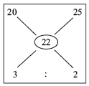

Therefore, the ratio of Desi Coffee is to Videshi Coffee is 3 : 2.

17. (b) : After operation I, glycerine = *x* − 1 and water = 1.

After operation II, glycerine =  and water =.

According to the given condition,



⇒ 2*x* − 1 = 3(*x*2 − 2*x* + 1) ⇒ 3*x*2 − 8*x* + 4 = 0

⇒ (3*x* − 2) (*x* − 2) = 0 ⇒ *x* =  or 2

*x* =  is not possible, since 1 litre glycerine was taken out.

So, *x* = 2.

⇒ Final quantity of glycerine in the mixture

= 

18. (d) : At the end of the 1st process alcohol content

= 

∴ Alcohol at the end of *n*th process = (0.8)*n*

Now, (0.8)*n* < 0.5, (0.8)4 = 0.4096 < 0.5

∴ *n* = 4.

19. (b) : Use alligation methods on fraction of syrup in two vessels.

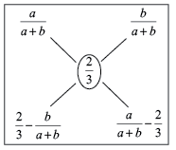

Required ratio = 

= (2*a* − *b*) : (*a* + 2*b*)

20. (b) : Let *a*, *b*, *x* and *y* denote the volumes of *A*, *B*, *X* and *Y* respectively.

*x* =  ⇒ *y* = 

40 operations must have tranferred (*x* − *y*) × 40 litres from *B* to *A*, i.e. 

Now, there are 10 litres in *A* and 10 litres in *B*.

∴ Total volume = 10 + 10 = 20 litres. Hence, option (b) is right answer.

21. (d) : The amount of sugar in the cylinder = 1.5 litres

Now,  is the amount of sugar left after a litres has been replaced twice.

Now, after replacement, sugar left is 10% of the total solution *i.e*. 10% of 10 litres = 1 litres

∴ 

∴ 



∴ 

∴ 

∴ *a* = 2

Hence, option (d) is right answer.

22. (c) : For the resulting mixture to contain 20% acid content.

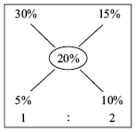



*x* = 300

∴ The mixture with 30% acid content to be added = 

= 

For the resulting mixture to contain 25% acid content.

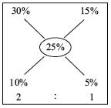



*x* = 600

∴ 

= 

Hence, the acid solution with 30% acid content may be added so that acid content in the resulting mixutre will be more than 20% but less than 25% should be more than 100 litres but less than 400 litres.

23. (c) : The two mixture are mixed in the ratio of 9 : 16 to get 100 litres mixture.

Let 9*x* and 16*x* be the quantities taken.

So, 9*x* + 16*x* = 100

*x* = 4

So, 9*x* *i.e*. 36 litres is taken from the first mixture and 16*x* *i.e*. 64 litres is taken from the second mixture.

Now, quantity of water in the resultant mixture

= 

Quantity of milk in the resultant mixture

= 

Now we take out 20 litres of solution and then we add 10 litres milk.

So, water = .8 (80) = 64

& milk = .8 (20) + 10 = 26

Now, we take out 9 litres of solution and then we add 5 litres milk.

So, water = .9 (64) = 57.6

& milk = .9 (26) + 5 = 28.4

Percentage of milk = 

24. (b) : Let the cask hold *x* gallons.

Petrol per gallon mixture after 2 operations = 

∴ 

 ⇒ *x* = 28 gallons

25. (c) : Cost of tea of the first kind = 

Cost of tea of the second kind = 

Cost of the mixture = 

*i.e.*,

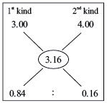

Required ratio = 

=